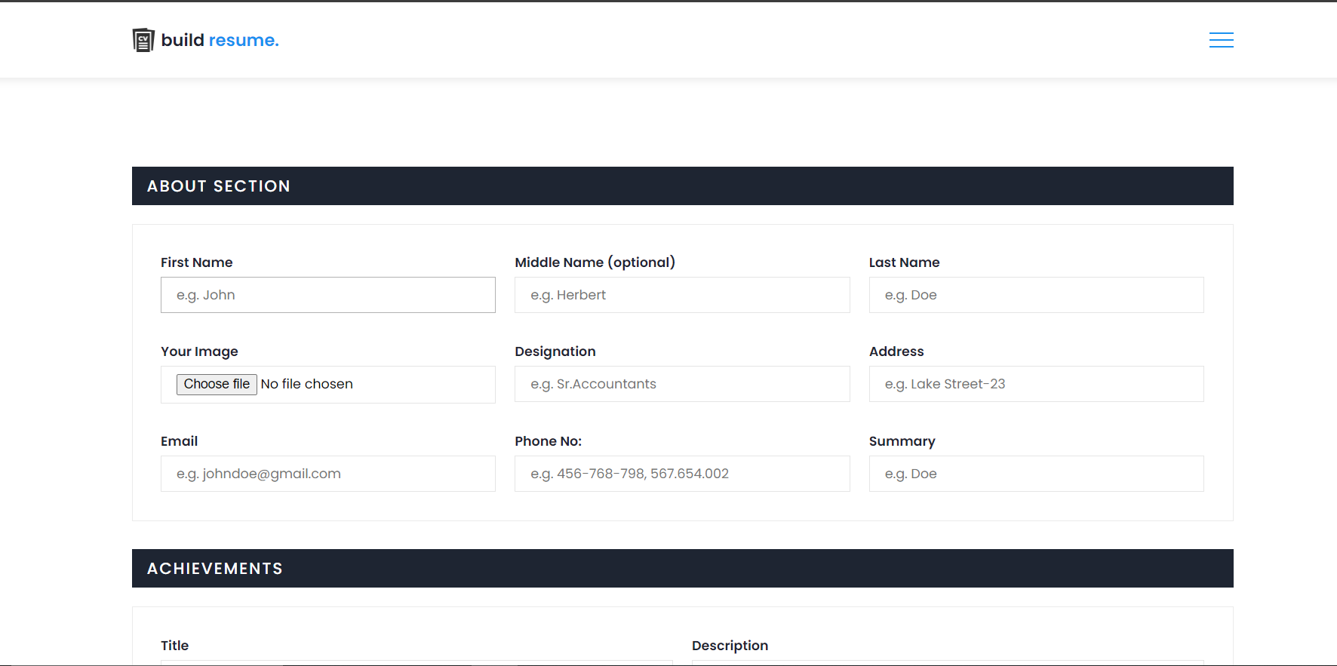

Figure.4.3.5. About Section

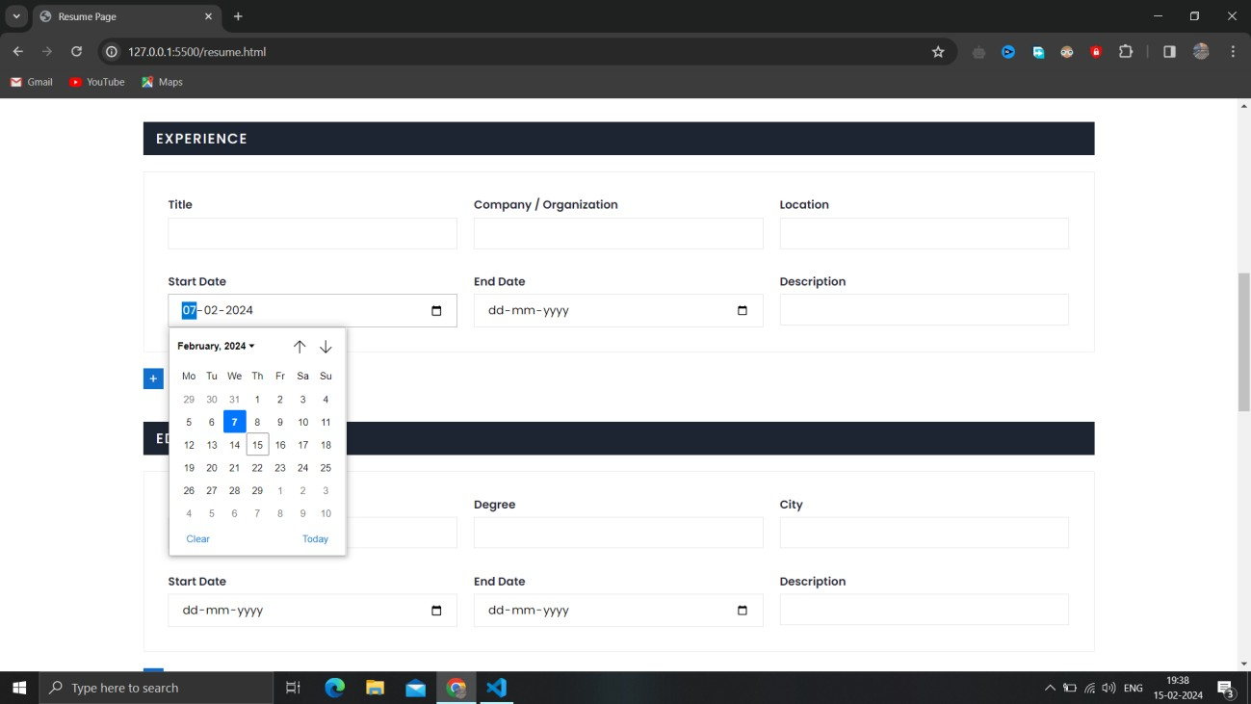

Figure.4.3.6. Calendar based date fixiation

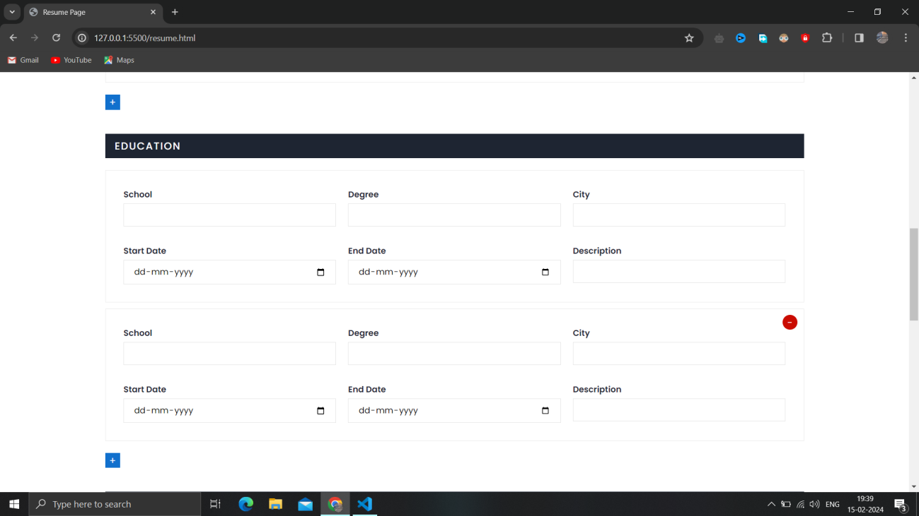

Figure.4.3.7. Minimization/Maximation of tabs.